|  |  |  |
| --- | --- | --- |
|  | **Faculty of Computing, Engineering and Science** | Final mark awarded:_____ |

**Assessment Cover Sheet and Feedback Form 2017-18**

|  |  |  |  |
| --- | --- | --- | --- |
| Module Code:  CS3S664 | Module Title:  Real-time Rendering Techniques | | Module Lecturer:  Carl Jones, Marius Miknis |
| Assessment Title:  3D Scene using DirectX | | | Assessment No.  2 |
| No. of pages submitted in total including this page:  Completed by student | | | Word Count of submission  (if applicable): Completed by student |
| Date Set:  22-Jan-2018 09:00:00 | | Submission Date:  02-Mar-2018 23:00:00 | Return Date:  30-Mar-2018 23:00:00 |

|  |  |
| --- | --- |
| ***Part A: Record of Submission (to be completed by Student)*** | |
| **Extenuating Circumstances**  If there are any exceptional circumstances that may have affected your ability to undertake or submit this assignment, make sure you contact the Advice Centre on your campus prior to your submission deadline. | |
| **Fit to sit policy**:  The University operates a fit to sit policy whereby you, in submitting or presenting yourself for an assessment, are declaring that you are fit to sit the assessment. You cannot subsequently claim that your performance in this assessment was affected by extenuating factors. | |
| **Plagiarism and Unfair Practice Declaration:**  By submitting this assessment, you declare that it is your own work and that the sources of information and material you have used (including the internet) have been fully identified and properly acknowledged as required[1]. Additionally, the work presented has not been submitted for any other assessment. You also understand that the Faculty reserves the right to investigate allegations of plagiarism or unfair practice which, if proven, could result in a fail in this assessment and may affect your progress. | |
| **Intellectual Property and Retention of Student Work:**  You understand that the University will retain a copy of any assessments submitted electronically for evidence and quality assurance purposes; requests for the removal of assessments will only be considered if the work contains information that is either politically and/or commercially sensitive (as determined by the University) and where requests are made by the relevant module leader or dissertation supervisor. | |
| **Details of Submission:**  Note that all work handed in after the submission date and within 5 working days will be capped at 40%[2]. No marks will be awarded if the assessment is submitted after the late submission date unless extenuating circumstances are applied for and accepted (Advice Centre to be consulted). | |
| You are required to acknowledge that you have read the above statements by writing your student number(s) in the box: | Student Number(s):  14010089 |

**IT IS YOUR RESPONSIBILITY TO KEEP RECORDS OF ALL WORK SUBMITTED**

|  |
| --- |
| **Part B: Marking and Assessment**  **(to be completed by Module Lecturer)** |
| This assignment will be marked out of 100%  This assignment contributes to 60% of the total module marks.  This assignment is bonded |
| **Learning Outcomes to be assessed** (as specified in the validated module descriptor <https://icis.southwales.ac.uk/> ):  *1) To be able to analyse and critically evaluate techniques used to render 3D scenes in real-time 2) To design, implement and evaluate GPU shaders in order to render effects in real-time* |

|  |  |  |
| --- | --- | --- |
| **Feedback/feed-forward** (linked to assessment criteria):   * Areas where you have done well: * Feedback from this assessment to help you to improve future assessments: * Other comments | | |
| **Mark:** | **Marker’s Signature:** | **Date:** |
| * **Work on this module has been marked, double marked/moderated in line with USW procedures.** | | |
| *Provisional mark only: subject to change and/or confirmation by the Assessment Board* | | |

|  |  |
| --- | --- |
| **Part C: Reflections on Assessment**  **(to be completed by student – optional)** | |
| **Use of previous feedback:**  In this assessment, I have taken/took note of the following points in feedback on previous work: | |
| **Please indicate which of the following you feel/felt applies/applied to your submitted work**   * A reasonable attempt. I could have developed some of the   sections further.   * A good attempt, displaying my understanding and learning, with   analysis in some parts.   * A very good attempt. The work demonstrates my clear   understanding of the learning supported by relevant literature and  scholarly work with good analysis and evaluation.   * An excellent attempt, with clear application of literature and   scholarly work, demonstrating significant analysis and evaluation. | |
| **What I found most difficult about this assessment:** |  |
| **The areas where I would value/would have valued feedback:** |  |

|  |  |  |  |  |  |  |
| --- | --- | --- | --- | --- | --- | --- |
|  | Fail | Narrow Fail | 3rd Class / Pass | Lower 2nd Class / Pass | Upper 2nd Class / Merit | 1st Class / Distinction |
| 1. Implementation 50% | * No objects in scene. The overall quality of the final 3D scene is very poor * Only a few of the required rendering techniques have been implemented. A basic implementation showing only a rudimentary understanding of rendering techniques | * Only basic scene is implemented with no animation. The overall quality of the final 3D scene is very poor * Only a few of the required rendering techniques have been implemented. The implementation is basic showing some understanding of rendering techniques | * Only basic scene is implemented with limited animation of objects. The overall quality of the final 3D scene is poor * Most of the required rendering techniques have been implemented. The implementation is basic using only standard techniques | * A reasonable scene is implemented with limited animation of objects. The scene is coherent and is of good visual quality * A good implementation using all of the required techniques is presented showing sound understanding of the techniques | * A comprehensive scene is created with numerous elements animated. The scene is coherent and of high quality * A very good implementation using most of the listed techniques is presented demonstrating a good understanding | * A comprehensive and coherent scene is created with numerous elements animated. The visual appearance is of excellent quality * All of the required rendering techniques have been implemented to good effect in the scene. The techniques implemented have been improved upon the tutorial code. Additional techniques might have been researched and implemented |
| 2.Discussion of each Rendering Techniques 15% | * Very poor 2.Discussion of each Rendering Techniques. . Little or no discussion on how the techniques might be improved upon is given | * Poor 2.Discussion of each Rendering Techniques. . Little or no discussion on how the techniques might be improved upon is given | * Satisfactory 2.Discussion of each Rendering Techniques the student demonstrates a limited understanding of the rendering techniques used. A basic discussion on how the techniques might be improved upon is given | * Good 2.Discussion of each Rendering TechniquesA good discussion on the techniques is presented, showing some understanding of the techniques used. A good discussion on how the techniques might be improved upon is also given | * Very good 2.Discussion of each Rendering Techniques. A detailed discussion on the techniques used is presented. A good discussion on how the techniques might be improved upon is also given | * Excellent 2 Discussion of each Rendering Techniques. An in-depth discussion on the techniques used is presented. A detailed discussion on how the techniques might be improved upon is also presented |
| 3.Discussion of efficiency of techniques Techniques 15% | * . Little or no discussion of the impact on the frame rate for the rendering techniques implemented is given | * . Little or no discussion of the impact on the frame rate for the rendering techniques implemented is given | * A basic discussion of the impact on the frame rate for the rendering techniques implemented is given | * A good discussion of the impact on the frame rate for the rendering techniques implemented is given, showing an understanding of the techniques used | * A good discussion of the impact on the frame rate for the rendering techniques implemented is given, showing an understanding of the techniques used | * A detailed discussion of the impact on the frame rate for the rendering techniques implemented is given, showing a very good understanding of the techniques used |
| Code Demo 20% | * Very poor Code Demo understanding of the code | * Poor Code Demo understanding of the code | * Code Demo satisfactory understanding of the code | * Code Demo good understanding of the code | * Very good Code Demo understanding of the code | * Excellent Code Demo understanding of the code |
|  | | | | | | |

Assessment Task:

You are required to implement a 3D Castle scene showing a courtyard, tower or dungeon for example that uses some of the rendering techniques discussed in lectures. The rendering techniques you should use in the creation of your scene are as follows

1.Texture mapping filtering, (e.g. anisotropic), normal mapping, environment mapping

2.Water Effect

You should also implement at least 1 of the following...

1.Foliage Effects

2.Particle Systems

3.Lighting and Glow effects

How the techniques are applied within the castle scene is left for the student to decide. For example, water effects can be used to create a moat or lava effect for example. You are required to implement the scene using the DirectX 11 API discussed in lectures and tutorials. Content for your scene can be created using procedural techniques or can be loaded from existing models using mesh import libraries.

You will also be required to explain your design and implementation in a short 5 minute code demo which will take place in the tutorial session after the assignment has been submitted.

You are also required to write a report that discusses the techniques used, and the impact the techniques have on the frame rate. For each technique, discuss different ways the desired effect can be achieved by looking at existing approaches in the literature. Discuss which approach you will implement and show screenshots of the final result. You are to then discuss the frame rate impact after each technique has been implemented. Discuss how the parameters used can be changed to improve frame rate (for example, different resolution textures or numbers of particles), and discuss how the implementation might be improved given more development time.

The report should be no longer that 1500 words, word processed and include appropriate references to the literature used.

Deliverables

1)A zip containing the source code and executable of your implementation. This is to be submitted to UniLearn no later than the submission date shown on the assignment front sheet. Please name your zip file with your enrolment number (e.g. 12345678.zip).

2)A word processed report discussing your implementation and evaluating the techniques used.

3)A copy of this document is also to be included in your zip file, with your Student Enrolment Number filled in on the front sheet and the optional Reflection sheet (see Part C below) filled in accordingly.

4)A 5-10 minute code demo discussing your implementation, the results obtained and the problems you faced in implementing the assignment.

**Anisotropic – Multisampling**

Taxing compared to no anti-aliasing but a much cheaper alternative than SSAA. The biggest downfall is that MSAA calculates textures once per pixel, the resulting rendered polygons as a result of blending textures & pixel shaders may result in some aliasing still existing. The good thing is that it cuts down on a lot of the computational requirements that would otherwise have to be done allowing for a good visual/performance method of reducing anti-aliasing.

**Possible improvements**

SSAA gives the best image quality & is great for what MSAA lacks, that being good shader aliasing. Since SSAA works by rendering a scene at higher resolution than its native & then downscaling it to its original resolution it gets extremely resource demanding but for the purpose of making a scene look as realistic as possible this could be a better alternative. For each pixel for SSAA you need to run the shader multiple times which yields great results however the drawback to performance is its downfall. Like all antialiasing techniques, as you increase the sample size the quality difference becomes less noticeable while how demanding on resources become a lot more obvious. It’s a matter of finding a good balance between the 2 in order to get the best experience. Ambient occlusion is something that can also be done in order to improve how realistic the scene looks that greatly improves lighting simulation.

**Normal mapping – Terrain normal mapping**

To add to the scenes realism, I decided to create my own bump map in photoshop & generated a normal map from it. I then used the bump/normal mapping as shown below & applied them to the once was flat terrain to give it height. The darker it is, the lower the height at that point is & vice versa.

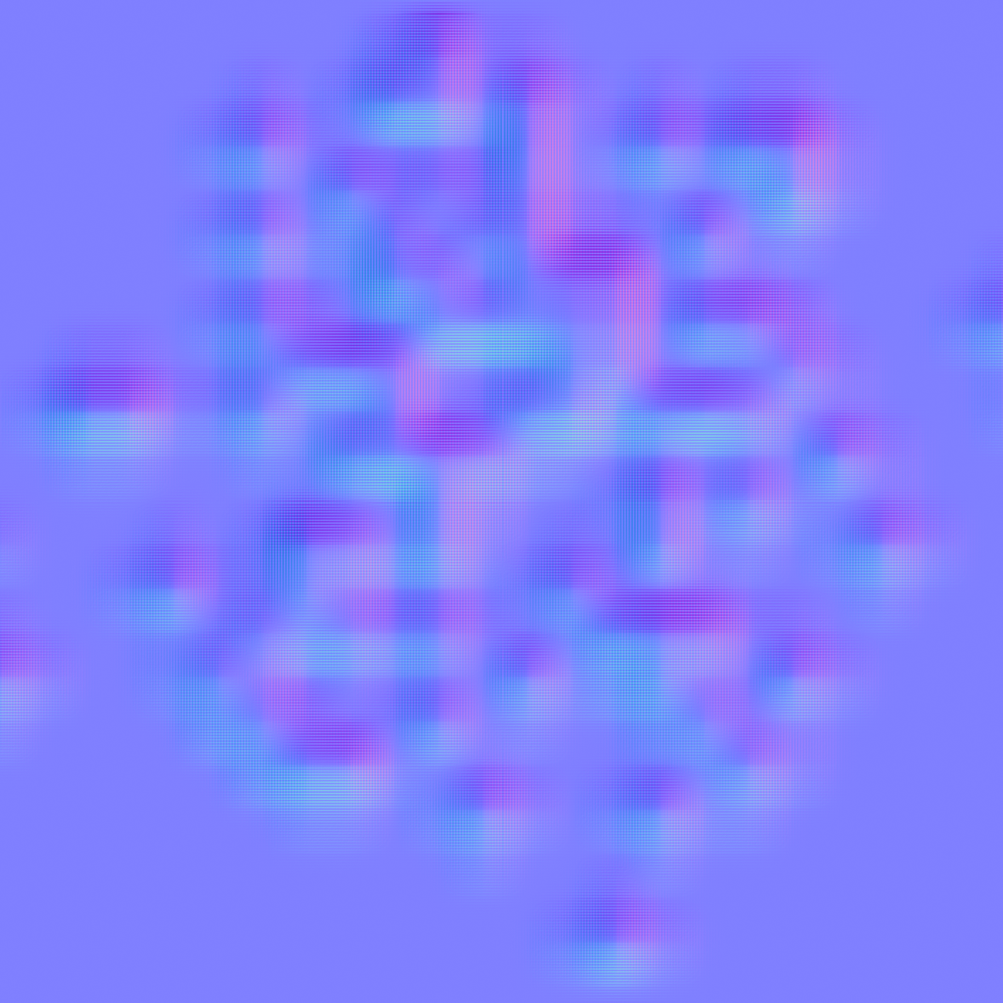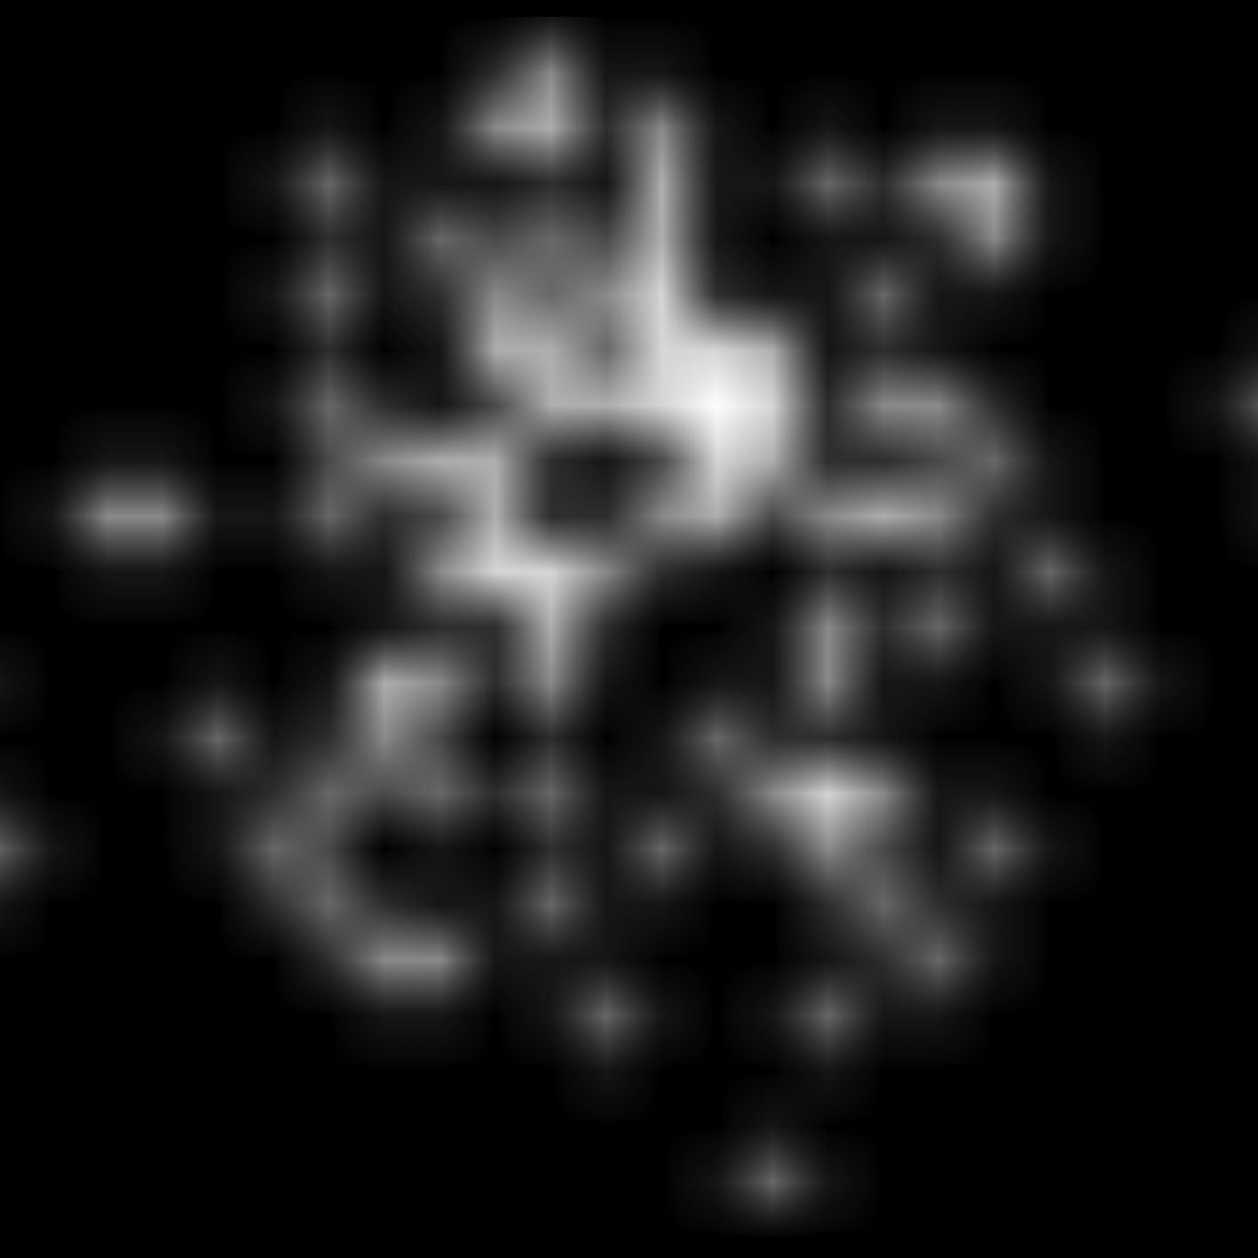

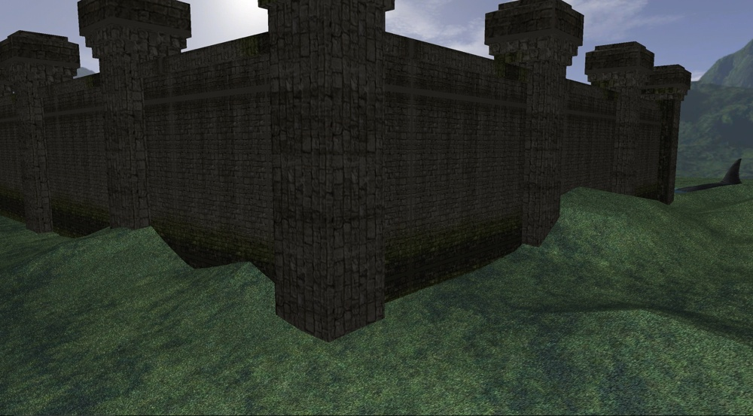

Terrain height example

Bump map

Normal map

The good thing about using bump/normal maps is you don’t have to rely on high-resolution models. All of the models’ surface detail is normal mapped to then be applied to a lower resolution model. This improves frame rates while gives us the illusion that the model is of high-resolution & therefore still look realistic.

**Possible improvements**



Tangent map

Tangent space & object space are two types of normal mapping. The normal map picture shown is an example of tangent space normal map. They’re great for models that change/deform e.g. if my shark where to eat people then the change in the models eating animation would require tangent space normal mapping.

Object space normal mapping is good for models that don’t need to deform & would result in better performance/frame-rate since the computational time used to transform light direction into tangent space wouldn’t be needed.

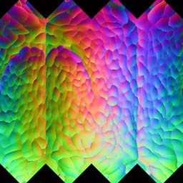

Object space

**Environment mapping – Cube mapping**

The environment in which everything is made in, is called a skybox. Cube mapping is a rendering technique which allows me to give the illusion that the skybox is bigger than what it is while also making it more realistic e.g. not just a simple black environment. This skybox is made up of 6 sides, all having slight connections with each other so that 1 face of the skybox matches up with the other faces e.g. If only half of a cloud is on 1 side of the face, the rest of it needs to be follow through on the next side so to not break the realism.

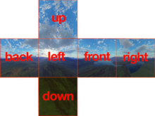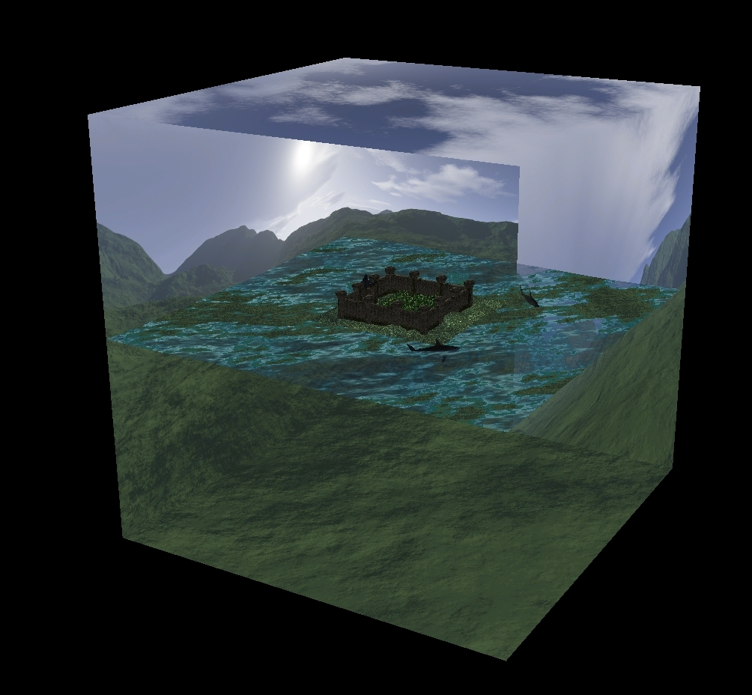

**Possible improvements**

In its current state the skybox is static in that as time passes there’s no change to it to make it feel like a more realistic environment. A transition between night/day & seeing day to day thing we experience ourselves like clouds moving would make it feel more realistic. The skybox isn’t that great at the moment either & 3D geometry like building can be used to add another layer of depth to the skybox making the skybox look even further away.

**Water Effects – Ocean**

Used in my scene as an ocean effect with rippling waves to make it look more realistic. The ripple effects randomise between 3 different intensities to make it seem more dynamic & realistic. A Fresnel calculation is done in retrospect of the skybox reflection in order to determine how transparent the water is at different angles. When looking at the water e.g. straight down it’ll be more transparent while as you start to look at it at a more acute angle you’ll see the reflection more & more & transparency reduce.

**Possible improvements**

A possible improvement could be to have it affected by external factors e.g. the sharks. Currently how the ripples in the water move are unaffected by this but in reality, they would & implementing that would make it more realistic. The same goes for anything else that may interact with the water if that were to be developed.

**Foliage effects – Trees/Grass**

Animated grass & trees that sway to give the illusion there’s wind. The base of the tree/grass sways less compared to the top similar to how it would in reality.

**Possible improvements**

At the moment the tree placement is based on a predetermined height value rather than the height of the terrain. Using the terrain height bump map, they could be placed depending on the terrain height. This will also make it more realistic as trees aren’t always the same height. The use of different trees & randomising them would also be an improvement. Different animations for the swaying of the grass & trees could be introduced so if e.g. it’s very windy the intensity of how much they sway could be increased to show that & likewise if there’s little wind.

**Particle systems – Fire/smoke**

I’m using aparametric particle system to create the fire/smoke. The result of this is placed in the logs to make them look like they’re on fire. A second particle system is used with the smoke texture to further improve how realistic the fire looks since where there’s fire, there’s also smoke. The flame/smoke effect is created using a vertex shader.

The particle positions billboard (since the fire/smoke is actually 2d) are transformed to face the viewport so that as you turn the viewport the billboard is always facing the camera to give a 3d like effect, alpha blending is enabled & depth stencil writing is disabled.

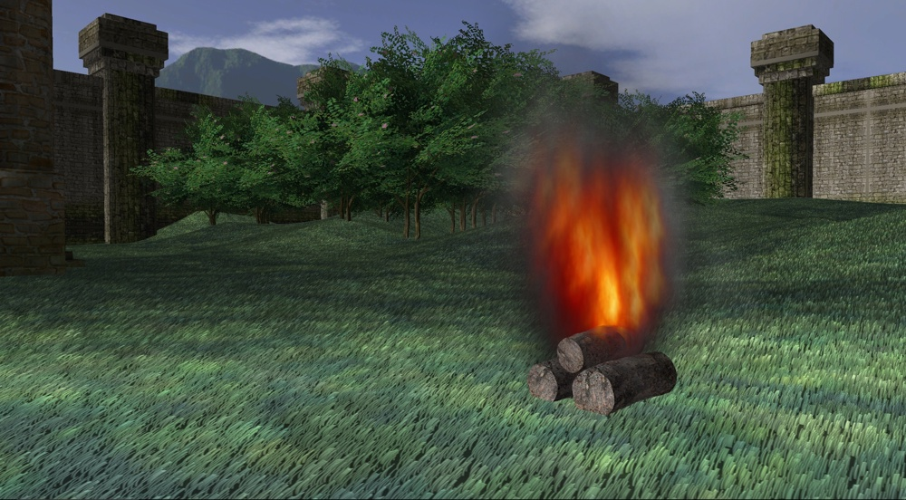

=

+

**Possible improvements**

Currently how the particles move is fixed & therefore predictable, adding some randomness to it would help improve it. Since the fire/smoke is 2D it’ll also be noticeable when viewed from above which isn’t realistic.

**Different ways the desired effect can be approached**

The castle walls are 12 objects reused & repositioned to give the effect of it being 1 structure. Since I haven’t added any interactive functionality or used additional rendering techniques such as LOD or Occlusion culling a better approach would have been to make it 1 model. This would reduce the coding required while also increasing the framerate.

**Discuss how the parameters used can be changed to improve frame rate (for example, different resolution textures or numbers of particles).**

There are a few rendering techniques that can be applied in order to improve frame rate.

# **Level of detail (LOD)** “ID3D11DeviceContext::SetResourceMinLOD” method is a rendering technique, useful for reducing a 3D model’s complexity in order to improve performance. Models such as my castle are converted to triangles because convex shapes are easy to rasterise. More detailed models require more triangles which means more rendering needs to be done. LOD helps to improve performance by using lower level detailed models. At close, model details are more noticeable but as you start to move away it become more difficult to notice & so by using lower & lower detailed models the further you are away, you gain the benefit of improving performance without the reduction of realism being too noticeable. The use of different resolution textures & number of particles can also be altered depending on how close/far the view on the scene is e.g. at close to let’s say the logs, fire, smoke it could be at its maximum assigned resolution/particles but as the user zooms out what resolution texture & number of particles being used to simulate the fire/smoke etc can be reduced. By implementing all of these & applying it to all objects in the scene it’ll make it less demanding on the graphics pipeline & therefore boost frame rate.

**Occlusion Culling** “D3D11_QUERY_OCCLUSION” method, is another rendering technique in which disables the rendering of object when not visible & could be used to further improve frame rate. Using a screenshot of my work as an example as shown below, you can see a lot of other objects in the world such as the sharks/water & some of the castle walls can’t be seen however they still exist & at the moment are unnecessarily still being rendered which negatively impacts framerate. By not rendering what can’t be seen the amount of stuff needing to be rendered is drastically reduced & framerates can improve. This makes the most difference in small but congestive areas. There’s also Frustum culling which would have similar effect however that only disables rendering of things outside the camera’s view so would still render something e.g. behind the logs in this example of the screenshot below.



**Discuss how the implementation might be improved given more development time.**

Given more development time the implementation could have been improved both graphically & performance-wise. **Graphically** something like

* a day/night cycle could be implemented by introducing dynamic cube mapping
* better rendering of objects such as the placement of trees being based on the terrain height rather than a predetermined height value
* interactables such as a drawbridge, being able to open close castle doors or being able to change settings to preview the same scene but under different conditions such as whether e.g. sun/snow/raining
* Instead of a camera, having a playable character which can move around & interact with those interactables changes I mentioned above.
* More detailed Models/textures/particle systems
* Dynamic environments e.g. the logs actually burning up & disappearing over time, also destructible objects such as being able to knock down the castle or kill a shark etc.
* Artificial intelligence so that things in the environment can impact the user if playing as a character in the scene e.g. a shark being able to chase & kill the user if they go into the water

All these are some examples of how it can become & feel more realistic.

**Performance-wise** given more development time I could:

* Use additional rendering techniques I previously mentioned such as LOD & Occlusion Culling. Rendering techniques like these become even more beneficial when being used in complex resource intensive scenes as it can potentially drastically reduce the amount of stuff needing rendering or/and the detail might not have to e.g. render a lot if not a lot of stuff isn’t in view or is far from view etc.
* There are also other ways to improve upon performance however it varies by the hardware that’s running it e.g. on a multi-core CPUs the use of a deferred context method “ID3D11Device::CreateDeferredContext” (used to record command lists) can be used to allow some of the rendering to be done concurrently with the main thread. Since not all computer are multi-core it would be more beneficial to first implement other rendering techniques like the LOD & Occlusion culling first as there’s no hardware restriction & so every user can benefit from those compared to this.

**Frame rate impact after each technique has been implemented**

I only rendered 1 thing at a time to get a better idea on how much each rendering technique impacted the FPS. To start I rendered nothing onscreen to get an idea of the initial FPS I would get.

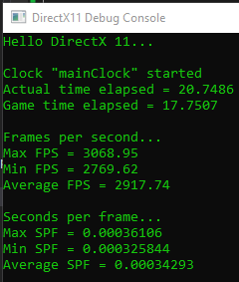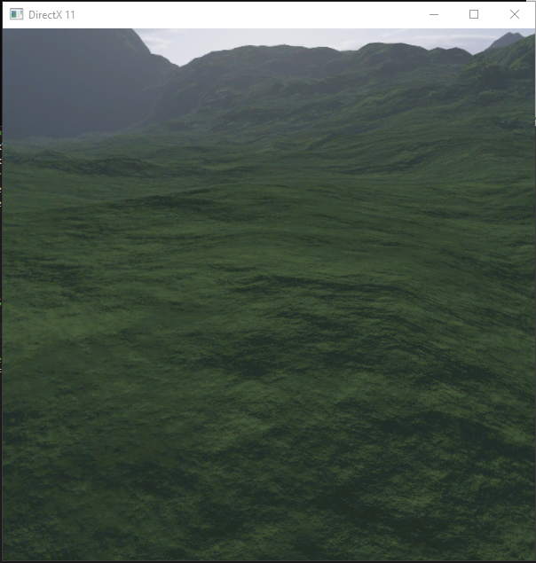

This is where only the skybox was applied. As you can see the FPS isn’t affected too much

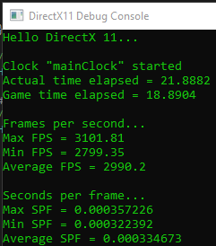

This gives us the best PFS across the board as nothing is being rendered. It’ll be used to compare FPS.

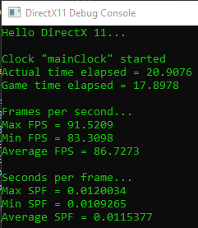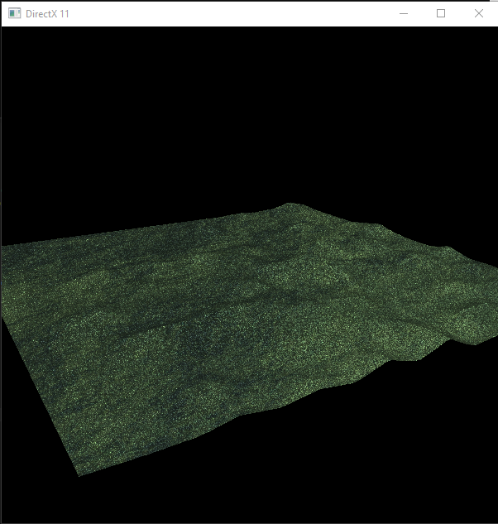

This is where we get a massive dip in FPS. Animating all the grass is very computationally intensive. Although it’s a massive drop in FPS, it’s rather stable with a small FPS difference between MAX & MIN.

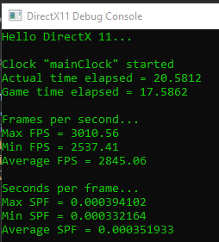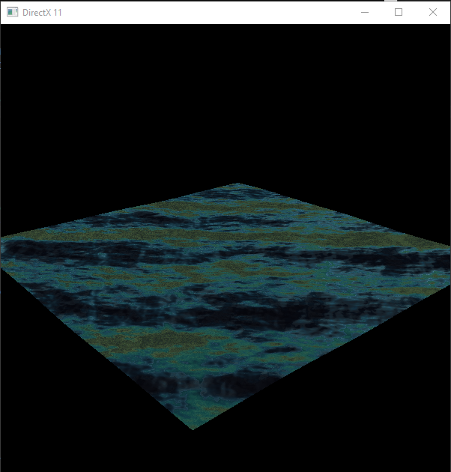

Doesn’t affect the average FPS too much however it seems to affect the MIN FPS a lot which if FPS became a problem could result in minimum FPS drops being noticeable & breaking the realism

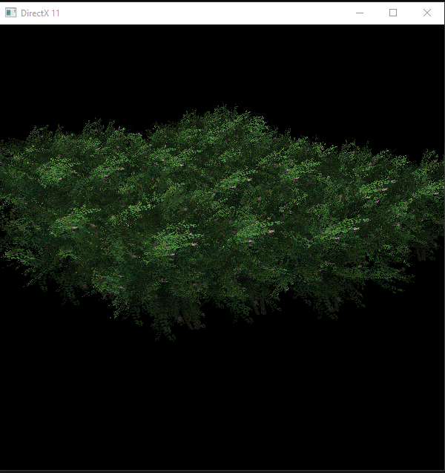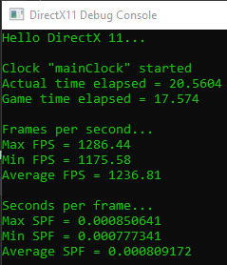

Moderate FPS hit as it’s also highly computational

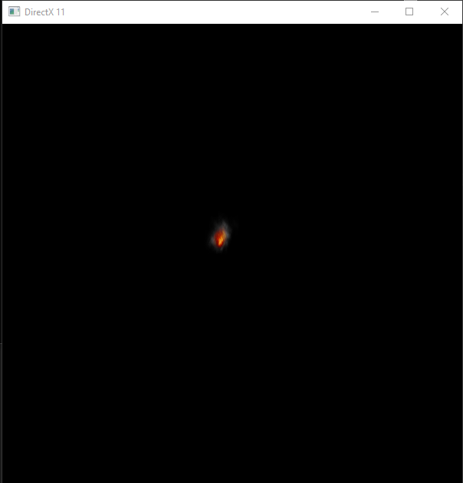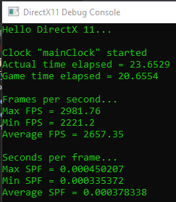

Moderate FPS hit as it’s also highly computational considering it’s just 1 instance of this technique being used.

From looking at this, animated foliage seems to have the biggest impact for frame rate & therefore performance. In order to improve this additional rendering techniques such as applying occlusion culling to foliage would be the biggest benefit for increasing performance.

**Screenshots of the final result**

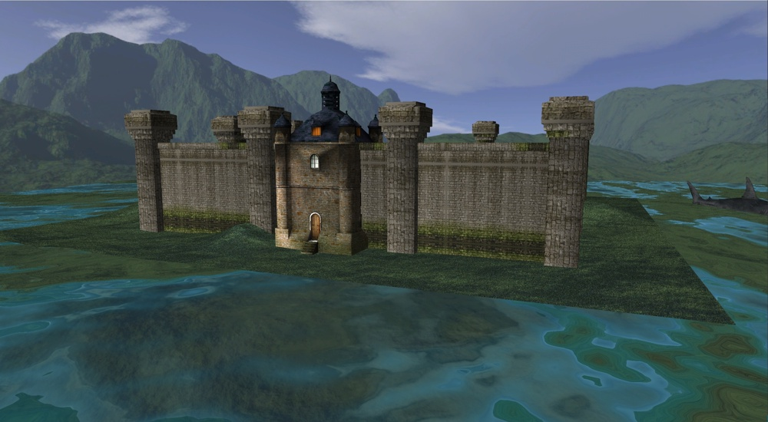

Screenshot of the castle

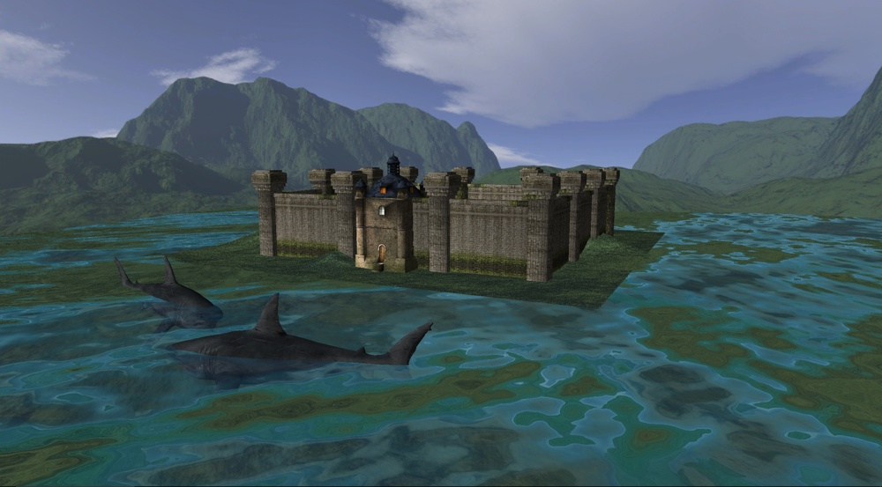



Screenshot of the sharks swimming around the castle

Screenshot of the particle system in play. Fire & smoke giving the illusion the logs are set on fire & are burning. It adds to the realism of the scene.

Terrain normal mapping.

Generated my own normal maps from diffuse textures. Once flat but now given the terrain height to further add to the realism of the scene.



1. University Academic Misconduct Regulations
2. Information on exclusions to this rule is available from the Advice Centre at each Campus